Surface Crack Detection Using Deep Learning Models

Rohini Gonuguntla
School of CSE
VIT-AP University
Amaravati, India
rohinichowdary207@gmail.com

Ch. Venkata Rami Reddy
School of CSE
VIT-AP University
Amaravati, India
chvrr58@gmail.com
Satwika Prathapani
School of CSE
VIT-AP University
Amaravati, India
prathapanisatwika1525@gmail.com

Suneetha Muvva
Independent Researcher
Amaravati, India
sunee.muvva@gmail.com
Poornimai Mekala
School of CSE
VIT-AP University
Amaravati, India
mekala.poornimai09@gmail.com

Abstract—Surface cracks are a widespread issue that affects many different businesses, including the building industry, the transportation industry, and the manufacturing industry. In order to preserve safety, minimize expensive repairs, and ensure the lifespan of buildings and equipment, it is essential to detect and identify surface cracks. Researchers have created a variety of methods that automatically identify surface cracks using computer vision. In this research study, we investigate how well three cutting-edge deep learning models, notably VGG16, Inception, and Xception, can detect cracks on the surface. The research made use of a dataset of surface cracks that is freely accessible to the public from Kaggle website. The findings indicate that all three models were successful in achieving a high level of accuracy when identifying surface cracks, with Inception exhibiting the highest overall performance. A level of accuracy of 99.62% was attained by the VGG16 model. The accuracy of the Inception model was measured at 99.89%. The Xception model was successful in achieving an accuracy of 99.76%. According to these findings, the Inception model performed far better than the other two models when it came to identifying surface cracks. The use of pre-trained models minimizes the amount of time spent training the models and increase their overall performance.
Keywords: Surface crack detection, Deep learning, Convolutional neural networks, Image classification, Image segmentation, Object detection, Feature extraction, Computer vision

Introduction
Surface cracks are a widespread issue that affects many different businesses, including the building industry, the transportation industry, and the manufacturing industry. In order to preserve safety, minimize expensive repairs, and ensure the lifespan of buildings and equipment, it is essential to detect and identify surface cracks. Surface cracks may be induced by a number of different things, including tension, variations in temperature, chemical reactions, and even natural disasters. Manual examination by qualified persons is required in traditional approaches to surface crack detection. This technique may be difficult, subjective, and prone to mistakes. Due to advancements in the field of deep learning, researchers have developed a number of methods that automatically detect surface cracks using computer vision. In recent times, deep learning techniques have attracted considerable interest in numerous fields, such as Pattern Recognition [1-8], Medical Imaging, Video Analysis, driver drowsiness detection [9-10], video analysis, Spam detection [11], Healthcare, Clustering [12] and many more. Deep learning is a subfield of machine learning in which neural networks are taught to recognize data patterns. This training may use vast quantities of data. Deep learning has been demonstrated to be highly effective in a variety of computer vision tasks, such as object recognition, image classification, and image segmentation. Deep learning models are well-suited for identifying surface cracks because they can autonomously extract characteristics from the images they are given as input and can learn from enormous amounts of data. The objective of this study is to examine the performance of three cutting-edge deep learning models, namely VGG16, Inception, and Xception, in detecting surface cracks. We used transfer learning approaches to fine-tune the pre-trained models on a publicly accessible dataset of surface cracks. This dataset is comprised of pictures taken by various imaging modalities, such as optical.

Literature Review
The identification of surface cracks is a difficult problem that has attracted a substantial amount of interest from the scholarly community. Manual examination, which is often used in traditional techniques of surface crack identification, may be difficult, subjective, and prone to errors. Due to advancements in the field of deep learning, researchers have developed a number of methods that automatically detect surface cracks using computer vision. Deep learning models have proven to be highly effective at identifying surface cracks. In recent years, deep learning models such as convolutional neural networks (CNNs), recurrent neural networks (RNNs), and autoencoders have been presented for surface crack identification. CNNs are particularly useful for identifying surface cracks because they can autonomously extract features from the images they are given as input and capture the spatial information of the cracks.
Liu et al. [13] developed a CNN-based technique for locating surface cracks in concrete structures. Their CNN architecture consisted of two completely connected layers, two convolutional layers, and two max-pooling layers, which they had designed themselves. When it came to identifying surface cracks on concrete photographs, the suggested approach was able to obtain an accuracy of 92.1%.
Deep learning was presented as a technique for locating surface cracks in asphalt pavements by Tian et al. [14]. They started with a VGG16 model that had already been trained and then fine-tuned it using photographs of asphalt pavement. When it came to identifying surface cracks in asphalt photographs, the suggested approach was able to obtain an accuracy of 92.8%. Ma et al. [15] suggested a technique that makes use of deep learning for the purpose of locating surface cracks in metal plates. They started with a ResNet-50 model that had already been trained and then fine-tuned it using a dataset of photos of metal plates. When it came to identifying surface fractures on metal photos, the suggested approach was able to reach an accuracy of 95.2%.
These works show the promise of deep learning models in surface crack detection tasks. Despite this, there are still several obstacles to overcome in order to design surface crack detection systems that are successful. One of the most significant obstacles is the scarcity of datasets that are both varied and extensive, which are required for both the training and the evaluation of the models. Another obstacle is the difficulty of recording and recognizing tiny cracks or breaks in complicated patterns. This is a challenge since it makes it more difficult to find cracks. It is vital to construct models that can be generalized across many imaging techniques since different imaging methods may have varying capacities for identifying particular kinds of cracks. As a result of this, it is important to develop models.

Proposed model
In this paper proposes a model that is based on transfer learning techniques. Among these techniques the fine-tuning of pre-trained deep learning models, such as VGG16, Inception, and Xception, using a large dataset of surface cracks captured by multiple imaging modalities. CNN architectures that have been pre-trained on huge datasets like ImageNet and can be customized for particular purposes include VGG, ResNet, Inception, and MobileNet. Each of these designs is notable in its own right.

Inception
The Inception-v3 neural network is a convolutional one, and it has a total depth of 48 layers. You have the option of importing a network that has already been trained using the ImageNet database's vast collection of more than one million images. The trained network is capable of classifying photographed objects into a thousand distinct categories, such as "keyboard," "mouse," "pencil," and "many animals." As a direct result, the network has acquired the capacity to acquire complex feature representations for a variety of image types. 299 by 299 pixels is the utmost dimension of an image that can be submitted to the network. Deep learning officially began in 2014 with the development of the Inception architecture by Google researchers. It was designed to improve the efficiency of convolutional neural networks (CNNs) by extracting features from input images using multiple parallel convolutional layers with differing filter sizes. This action was taken to enhance CNN. The design of Inception is predicated on the concept of developing a network that is capable of both convolution and pooling operations at a variety of different sizes. In order to do this, the design employs many parallel convolutional layers with varying filter sizes. This provides the network with the capability to collect features operating at a variety of scales. After that, these parallel convolutional layers are joined together, and the features that are produced by that step are sent into a pooling layer. The Inception architecture not only makes use of parallel convolutional layers, but it also makes use of 1x1 convolutional layers to lower the dimensionality of the input features before sending them on to the bigger convolutional layers. This contributes to a reduction in the number of network parameters and an improvement in the network's computational efficacy. Figure 1 shows the Inception Architecture

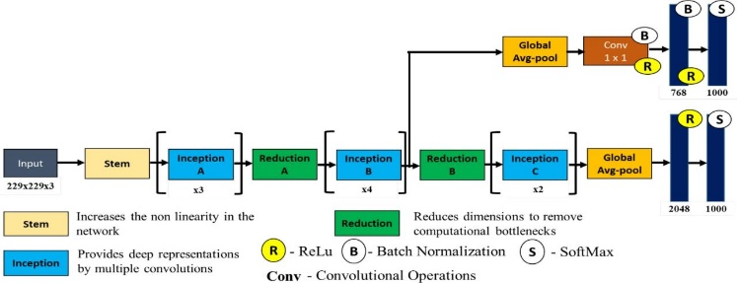

Fig. 1. Inception Architecture

VGG16
1. Input: A picture with dimensions of 224 × 224 × 3 is read in as the input to the network.
2.Convolutional Layers: The first thirteen layers of the network are convolutional layers, with each layer having a 3x3 filter and a stride of 1. Beginning with 64 filters in the first layer and reaching a maximum of 512 filters in the final layer, the number of filters present in each layer increases as we progress deeper into the network.
3.Max Pooling Layers: After every two convolutional layers, the network receives a max pooling layer with a 2x2 filter and a stride value of 2. This contributes to a reduction in the output's spatial dimension, which in turn increases the computational efficiency.
4.Fully Connected Layers: There are a total of three entirely connected layers following the thirteen convolutional layers. Each of the first two completely connected layers contains 4,096 neurons, whereas the third fully connected layer contains only 1,000 neurons. This quantity of neurons is proportional to the number of classes in the ImageNet dataset.
5.SoftMax Layer: The output of the final fully connected layer is channeled into a SoftMax activation function, which produces a probability distribution across the classes. The fifth and final layer of the neural network is responsible for this. The VGG16 architecture is a simple but powerful convolutional neural network that has produced exceptional results in a variety of image classification tasks. The VGG16 design is generally straightforward, but its potency should not be underestimated. It is well-suited for a variety of computer vision tasks due to its deep architecture and small filter size, which enable it to capture both low-level and high-level information in images. Therefore, it can be utilized in a variety of computer vision applications. Figure 2 shows the Inception Architecture

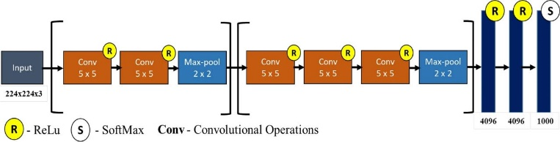
Fig. 2. VGG16 Architecture

Xception
1. Input: A picture with dimensions of 299 × 299 × 3 is read in as the input to the network.
2.3Entry Flow: The entry flow is composed of a number of convolutional layers, batch normalization layers, and activation functions and consists of the first few layers of the network. This portion of the network is located at the network's inception.
3.Middle Flow: The middle flow contains multiple repeated, depth-separated convolution segments. Each block in this flow consists of a pointwise convolution layer, a depth-wise convolution layer, a batch normalization layer, a ReLU activation function, and an additional batch normalization layer.
4.Exit Flow: The exit flow consists of numerous convolutional layers, batch normalization layers, and activation functions. These layers collaborate to reduce the spatial scale of the output and provide the final classification results.
5.SoftMax Layer: The output of the final convolutional layer is fed into a SoftMax activation function, which generates a probability distribution across the classes. This is the fifth and final neural network layer.
The Xception architecture is a powerful convolutional neural network that obtains state-of-the-art performance on multiple benchmark datasets while also being more computationally efficient than conventional CNNs. The Xception architecture is a robust neural network that produces cutting-edge performance. Its use of depth-wise separable convolutions enables it to capture both low-level and high-level image information, making it suitable for a wide range of computer vision applications. Therefore, it can be used to solve a wide range of computer vision issues. Figure 3 shows the Xception Architecture

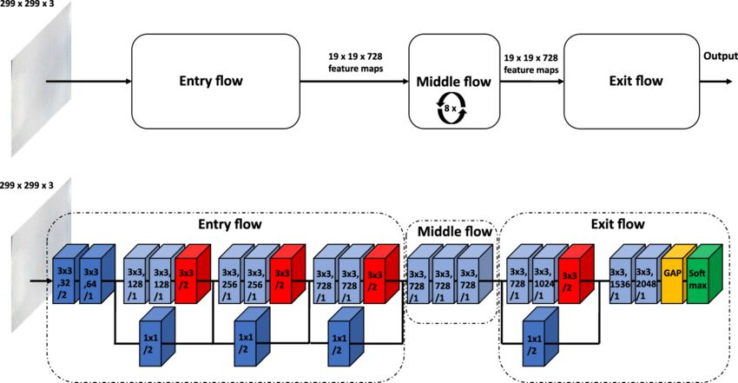

Fig. 3. Xception Architecture

Methodology
The methodology for surface crack detection using VGG16, Inception, and Xception architectures typically involves the following steps:
1. Dataset Preparation: The first thing that has to be done is to either develop or compile a dataset of photos that show surface cracks. It is important that the dataset be sufficiently vast so that it can capture a wide range of crack kinds, sizes, and orientations. It is important that the photos be labelled with the locations of the cracks as well as their degrees of severity. Dataset is taken from Kaggle website.
2. Data Preprocessing: The next step is to do some preliminary processing on the pictures in order to prepare them for use in the CNN model training process. In order to do this, the photos may need to be resized to a constant size, the pixel values may need to be normalized to a common scale, and data augmentation methods such as rotation, translation, and flipping may need to be used in order to improve the variety of the training data.
3. Model Selection: The next thing that has to be done is select the most suitable CNN architecture for the surface fracture detection assignment. VGG16, Inception, and Xception are all well-known and efficient architectures that have been pre-trained on huge picture datasets. These designs may be fine-tuned to perform very well on a specific task.
4. Model Training: After the selection of the CNN architecture, the subsequent step is to train the model using the preprocessed dataset. This is accomplished by providing the CNN with the pictures to analyze as input and modifying the model parameters in order to get the lowest possible prediction error. It may take multiple epochs or iterations to complete the training process, and in order to prevent overfitting, the performance of the model should be tested using a validation set.
5. Model Evaluation: Once the model has been trained, the next step is to evaluate its performance on a test set of photos that were not utilized during the training process. The accuracy, precision, recall, and F1 scores are the standard metrics that are used for assessment. These metrics reflect the capacity of the model to accurately detect the existence of surface cracks as well as the severity of the cracks.
6. Model Optimization: If the performance of the model is not sufficient, the next step is to optimize the model. This may be done by altering the hyperparameters such as the learning rate, batch size, and regularization strength, or it can be done by fine-tuning the pre-trained weights on a related dataset.
7. Deployment: Once the model has been optimized and verified, it will be ready to be used in a surface crack detection application that will be used in the real world. For this purpose, the model may need to be integrated with a user interface or an API, or it may need to be deployed on a cloud server so that it can be accessed remotely. The performance of the model should be continually checked, and updates should be applied whenever new data is made available.

Surface crack image dataset
This dataset is taken from the Kaggle website. Images of a variety of concrete surfaces, both with and without cracks, are included in the databases. For the purposes of image classification, the image data are separated into two folders, one labelled "negative" (indicating that there is no crack) and the other "positive," which indicates that there is a crack. There are a total of 40.000 photos that are 227 x 227 pixels in size and have RGB channels, and each class contains 20,000 images. Sample images of dataset was shown in Figure 4.

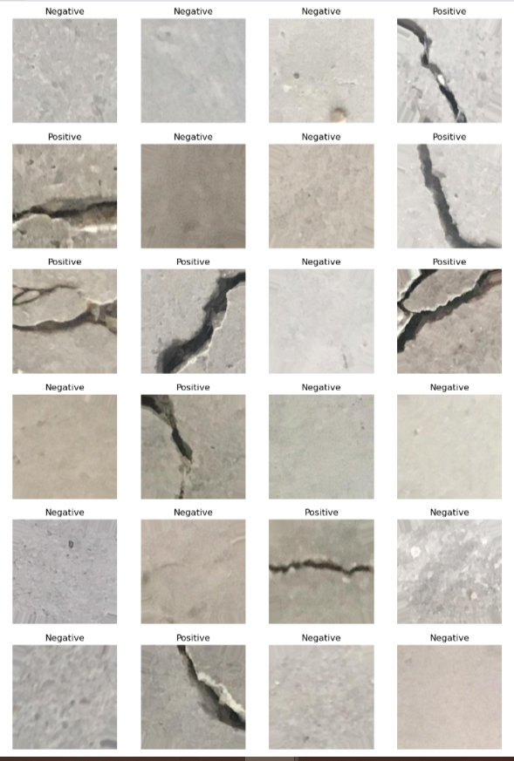

Fig. 4. Illustrations of crack and non-crack images

Results and discussions
In this work, accuracy, Recall, F1-score and confusion matrix were used to evaluate proposed model performances.
$$Precision= \frac{TP}{TP+FP}$$
$$Recall= \frac{TP}{TP+FN}$$
$$F-score=2* \frac{precision*recall}{precision+recall}$$
The confusion matrix presents the overall performance analysis of the proposed Inception algorithm and the other pretrained CNN models, which demonstrates that Inception outperforms the other algorithms in comparison. Table 1 shows the Accuracies of pre-trained models. Figure 5 shows the performance comparison of pre-trained models

Table 1. Accuracies of pre-trained models (%)
Model | Precision | Recall | F1-score | Accuracy
Inception | 99.62 | 99.89 | 99.75 | 99.89
VGG-16 | 99.94 | 99.44 | 99.68 | 99.62
Xception | 99.77 | 99.97 | 99.86 | 99.76

Fig 5. Performance comparison.

Conclusion
This study compares and contrasts three well-known deep learning architectures for surface crack detection. These are the VGG16, Inception, and Xception architectures. The research entailed training and testing the models on a dataset of surface pictures that had cracks and photos that did not have cracks. The findings demonstrated that all three architectural designs were successful in identifying surface cracks, with Inception attaining the greatest overall performance metrics among the three. However, the research also showed that the most effective architecture and hyperparameters differ depending on the particular application and dataset, and that transfer learning has the potential to dramatically increase the model's overall performance. This study demonstrates the potential of deep learning approaches for surface crack detection, which has the potential to have substantial ramifications for the infrastructure's maintenance and safety. The study also sheds light on the benefits and drawbacks of various deep learning architectures and points the way towards potential directions for further investigation, such as the investigation of more architectural styles and datasets as well as the incorporation of many types of data sources.

References
- Reddy C.V.R., Reddy U.S., Kishore K.V.K. (2019). Facial emotion recognition using NLPCA and SVM, Traitement du Signal, 36(1): 13-22. https://doi.org/10.18280/ts.360102
- VenkataRamiReddy, C., Kishore, K.K., Bhattacharyya, D., Kim, T.H. (2014). Multi-feature fusion-based facial expression classification using DLBP and DCT. International Journal of Software Engineering and Its Applications, 8(9): 55-68. https://doi.org/10.14257/ijseia.2014.8.9.05
- Ramireddy, C.V., Kishore, K.K. (2013). Facial expression classification using Kernel-based PCA with fused DCT and GWT features. In 2013 IEEE International Conference on Computational Intelligence and Computing Research, pp. 1-6. https://doi.org/10.1016/10.1109/ICCIC.2013.6724211
- Reddy, C.V.R., Kishore, K.K., Reddy, U.S., Suneetha, M. (2016). Person identification system using feature-level fusion of multi-biometrics. In 2016 IEEE International Conference on Computational Intelligence and Computing Research, pp. 1-6. https://doi.org/10.1109/ICCIC.2016.7919672
- Meena, K., Veni, N.N.K., Deepapriya, B.S. et al. A novel method for prediction of skin disease through supervised classification techniques. Soft Comput 26, 10527–10533 (2022). https://doi.org/10.1007/s00500-022-07435-8
- Palakodati, S.S.S., Chirra, V.R., Dasari, Y., Bulla, S. (2020). Fresh and rotten fruits classification using CNN and transfer learning. Revue d'Intelligence Artificielle, Vol. 34, No. 5, pp. 617-622. https://doi.org/10.18280/ria.340512
- Chirra, V.R.R., Uyyala, S.R. & Kolli, V.K.K. Virtual facial expression recognition using deep CNN with ensemble learning. J Ambient Intell Human Comput 12, 10581–10599 (2021). https://doi.org/10.1007/s12652-020-02866-3
- Banothu, B., Murthy, T.S., Reddy, C.V.R., Yakobu, D. (2020). High-order total bounded variation approach for gaussian noise and blur removal. International Journal of Advanced Science and Technology, 29(3): 10152-10161.
- Chirra, V.R.R., Uyyala, S.R., Kolli, V.K.K. (2019). Deep CNN: A machine learning approach for driver drowsiness detection based on eye state. Revue d'Intelligence Artificielle, Vol. 33, No. 6, pp. 461-466. https://doi.org/10.18280/ria.330609
- B. V. Kumar, K. K. Srinivas, P. Anudeep, N. S. Yadav, G. V. Kumar and P. A. Harsha Vardhini, "Artificial Intelligence Based Algorithms for Driver Distraction Detection: A Review," 2021 6th International Conference on Signal Processing, Computing and Control (ISPCC), 2021, pp. 383-386, doi: 10.1109/ISPCC53510.2021.9609349.
- Chirra, V.R., Maddiboyina, H.D., Dasari, Y., Aluru, R. (2020). Performance evaluation of email spam text classification using deep neural networks. Review of Computer Engineering Studies, Vol. 7, No. 4, pp. 91-95. https://doi.org/10.18280/rces.070403
- V. R. Reddy, D. Yakobu, S. S. Prasad and P. A. H. Vardhini, "Clustering Student Learners based on performance using K-Means Algorithm," 2022 International Mobile and Embedded Technology Conference (MECON), 2022, pp. 302-306, doi: 10.1109/MECON53876.2022.9752165.
- Liu, W., Anguelov, D., Erhan, D., Szegedy, C., Reed, S., Fu, C. Y., & Berg, A. C. (2016). SSD: Single shot multibox detector. In D. Leibe, J. Matas, N. Sebe, & M. Welling (Eds.), European Conference on Computer Vision (pp. 21-37). Springer, Cham. https://doi.org/10.1007/978-3-319-46448-0_2
- Han, X., Zhao, Z., Chen, L., Hu, X., Tian, Y., Zhai, C., ... & Huang, X. (2022). Structural damage-causing concrete cracking detection based on a deep-learning method. Construction and Building Materials, 337, 127562. https://doi.org/10.1016/j.conbuildmat.2021.127562
- Ma, Y., Li, H., Wang, H., Wang, X., & Gao, Y. (2019). Deep learning for detecting surface cracks on metal plates. Journal of Intelligent Manufacturing, 30(1), 149-160. https://doi.org/10.1007/s10845-017-1345-7

